Annual Awards
Banquet
March 12, 2023
Greater Twin Cities Golden Retriever Club
Lost Spur Golf & Event Center
Eagan, MN

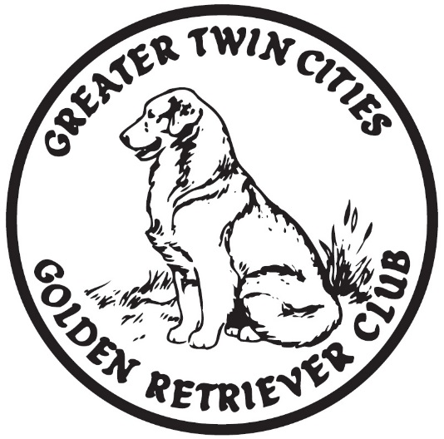
Congratulations to all of you on your new 2022 titles and many accomplishment

Program of Events
- Social Time 11:00am
- Brunch 11:30am
- Festivities and meeting to follow brunch
- Awards to follow meeting

Congratulations to last year’s
club award winners!

Show Dog of the year: GCH SixSigma’s It Happened Alluva Sutton CGC TKN
Owner: Deb Rahm

Field Dog of the year: Turbo’s Secret Explosion at Old Oak MH10
Owner: Andrea McConico

Obedience Dog of the year: Mirasol’s Owl About A Dream VCD2 UD AX AXJ JH
Owner: JoAnn Dalby

Agility Dog of the year: no applicants were received for the award-not awarded

New Title Certificates

CH DocMar R’Wok Paper Scissors RE BN SN DSA DM SIA SEA SCA CGC TKI (Vegas)
New Titles: CH DSA SIA SBN SEA SCA CGC
Special Honors: qualified for the National Dock Diving Championship in 2022
Owner: Laurie Hanson

OTCH Elmcreek’s Forever In My Heart UDX7 PUDX OGM BN VER CA CGC TKA ASCA-OTCH UDX Can. CDX RATN (Bristol)
New Title: RATN
Owner: Mary Leonard

Kokopelli’s Tears of Joy CGC DCAT TKI SWN SIA SBA NatCH IntCH HnRCH HnRCH-B (Lake)
New Titles: TKI SCN BCAT SEN SBN SIN SWN DCAT SIA SBA NatCH InTCH HnRCH HnRCH-B
Owner: Jaci Carufel

Hi-Star Striving For Excellence RE NAJ NF DS TKI CGC CCA (Excel)
New Titles: RE TKI CGC CCA
Owner: Nicole Wiebusch

RACH Hi-Star Exceeding All Expectations UD BN GO RM2 RAE2 AX OAJ XF DJ CGCA TKA PD WC CCA (Strive)
New Titles: RACH RM2 RAE2
Owners: Nicole and Lexi Wiebusch

Sunfire’s Precious Gem CGC (Ruby)
New Title: CGC
Owners: Anne and Jerome Reynolds

Sunfire’s Furry Race to Victory CD BN RN OA OAJ AXP AJP CGC TKI (Nike)
New Titles: AXP RN
Owner: Anne Reynolds

Mirasol’s Owl About A Dream VCD2 UDX3 OM5 BN RA JH AX AXJ NF CGC TKI VC WC CCA (Maya)
New Titles: UDX UDX2 UDX3 OM OM2 OM3 OM4 OM5
Owner: Joanne Dalby

GCH CH Goldrox Can’t Help Falling In Love With Blue RN THD CGC TKN (Blue)
New Titles: GCH RN THDN THD
Special Honors: NOHS BIS, #6 OH in 2022 (goldens)
Owners: Casey & Curtis Romano and Maura Roxby

OTCH3 Dream’s Jump Start UDX2 OM3 (Nudge)
New Titles: CD CDX UD OM OTCH UDX OM2 OTCH2 ODHF OM3 UDX3 OTCH3
Special Honors: Qualified for Master at the 2022 Classic, Qualified to attend obedience at 2023 Westminster, Qualified for the 2023 National Obedience Championship, #2 Golden in country for obedience for 2022
Owner: Kathleen Rasinowich

HRCH Emeline’s A Trip To Remember UDX OM2 BN MH WCX VCX OS CCA (Trip)
New Titles: UDX OM2 HRCH OS VCX
Owner: Susan Kluesner

SHR Wildwing’s Totally Engaged SH WCX CCA (Gage)
New Titles: SH WCX CCA
Owner: Susan Kluesner

OTCH Lakota Westmarch All Ashore UDX3 VER OM6 RAE RM OBHF (Dinah)
New Titles: RAE RM VER
Owner: Judy Super

RBIS U-CH Maple’s Fair-Haired Warrior CD BN RE SWE CGC TKI CCA (Finley)
New Titles: CD RE SWE
Special Honors: Qualified for the 2023 Rally National Championship
Owner: Charney Petroske

BOSS U-GCH Trademark’s A Million Riese-ns to Giggle DN DJ SEN SIN (Parker)
New Titles: SEN SIN
Special Honors: Qualified for the 2022 National Dock Diving Championship
Owners: Charney and Joe Petroske

In Memoriam
Gone, but not forgotten

CT-ATCH Sunwood’s What Goes Around Comes Around CD BN RAE AXP MJP OFP CA CGC TKI RATN CIA SEA SCA SWN (Karma)
Karma was the dog I waited for my whole life. She always tried her best in whatever she did. She loved life and everyone she met. I was always happy whenever we were together. I will always remember her trotting next to me and wagging her beautiful tail. I miss her so much.
Owner: Laurie Hanson

Rippling Run Old Oak Ready Set Go MH33 AX AXJ WCX CCA (Teya)
Teya was a wonderful hunt test dog-very reliable with a high pass rate. She competed because I asked her to but what she really loved was pheasant hunting. I joked once that I needed to get her a vest to wear at hunt tests that said “I’d rather be pheasant hunting.”
Owners: Andrea and Rick McConico

Old Oak’s Big Shoes to Fill SH WCX (Martha)
Martha lived to be 16 ½ years old. She died like she lived-quietly and peacefully at home. Martha was a quiet easy going dog who was the man on the totem pole at our house and she was just fine with that. A temperament and disposition to die for, a wonderful friend and companion. Always unassuming but she knew what she liked.
Owners: Andrea and Rick McConico

Amigold Minna-Soda Splash CDX JH WC RE Can. CD RN ASCA CD RE Flyball FMGCH 95K, Golden Versatility Award (Splash)
1/11/2009 to 12/6/2022
Splash was at many events for the golden retriever club including the State Fair. She was a good example for the golden retriever club.
Owner: Ed Pheifer

A Splash of Autumn Color CDX JH WCX Can. CD ASCA CD Flyball FMGCH 95K, Golden Versatility Award (Autumn)
6/4/2011 to 12/29/22
Owner: Mary Pheifer

Allie Mae’s Sierra Sunrise RI SWN TKI RATI (Sierra)
Sierra was from an unplanned litter of 15 golden puppies. Although she was an oops puppy she was clearly meant to be part of our family. She was a wonderful role model and mentor to many dogs over the years. Sierra was always up for anything. Her two favorite activities were scent work and swimming. Sierra went to the Rainbow Bridge ten days before her 15th Birthday. We treasure all the days we shared and miss her dearly.
Owners: Charney and Joe Petroske
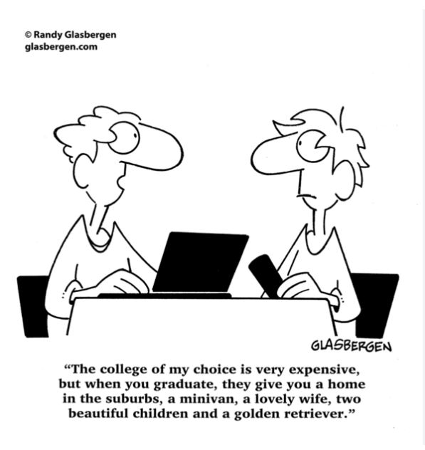

Thank you!
Thank you to our club officers, board members, event chairs and volunteers who helped put on the fun club events we had last year.
We would not be able to have any club events without our fantastic volunteers!

Thank you to the outgoing officers and board members:
Charney Petroski, Cindy Engler, Laurie Hanson, Andrea McConico.

Banquet Thank You To:
Deb Rahm and LuAnn Runkle for making this year’s banquet possible.

Rob and Laurie Hanson for the program and certificates

Kathy Rasinowich, Mick Dagendesh, Mindy Elledge and Dick Sheehan for their greatly appreciated contributions that helped make this year’s banquet a huge success.

