Annual Awards
Banquet
March 6, 2022
Greater Twin Cities Golden Retriever Club
Lost Spur Golf & Event Center
Eagan, MN

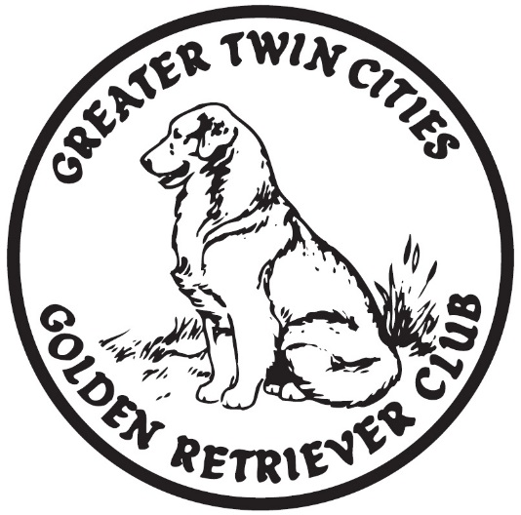
Congratulations to all of you on your new 2021 titles and many accomplishment

Program of Events
- Social Time 11:00am
- Brunch 11:30am
- Games and meeting to follow brunch
- Awards to follow meeting

New Title Certificates
CT-ATCH Sunwood's What Goes Around Comes Around CD BN RAE AXP MJP OFP CA CGC TKI RATN SIA SEA SCA SWN (Karma)
New Titles: CT-ATCH MJP SIA SEA SCA
Owner: Laurie Hanson and Colyn Leary

HR Emeline’s A Trip To Remember UD OM1 MH WCX VC CCA (Trip)
New Titles: HR OM1
Owner: Susan Kluesner

SHR Wildwing’s Totally Engaged JH WC (Gage)
New Titles: SHR JH WC
Owner: Susan Kluesner

RACH Mirasol Westmarch Beeyond This Moment UD BN GN GO RM2 RAE2 CGC TKN (Phred)
New Titles: UD RACH RM2 RAE2
Owner: Paula Ellis and Judy Super

Westmarch Frozen In Time CGC (Oaken)
New Title: CGC
Owner: Paula Ellis and Judy Super

HR Westmarch Garden Party UD BN RA SH CCA WCX (Ricki)
New Titles: CDX UD RN RA HR
Owner: Judy Super

OTCH Lakota Westmarch All Ashore UDX3 OM6 RE OBHF (Dinah)
New Titles: RE
Owner: Judy Super

Old Oak’s Hit The Jackpot SH (Jackie)
New Title: SH
Owner: Andrea McConico

Kokopelli’s Tears of Joy CGC TKN TKI IntJR HnrJR NatJR(Lake)
New Titles: CGC TKN TKI IntJR HnrJR NatJR
Owner: Jaci Carufel

DocMar R'Wok Paper Scissors RE BN SIN SCN SEN DM DS TKI (Vegas)
New Titles: SIN SCN SEN TKI
Owner: Laurie Hanson

AM.CAN.CH C-ATCH CS-ATCH Sunwood's Third Time's A Charm CD RE AX AXJ MXP NFP TKN RATI RATN SIN SCN SEN SBN OD (Chelsea)
New Titles: SCN SEN SBN
Owners: Robert, Laurie, and Jessica Hanson

CT-ATCH Sunwood’s Here We Go Again RAE BN AXP MJP2 OFP CGC CCA (Mia)
New Title: CT-ATCH
Owner: Kathy Godlewski

OTCH Elmcreek’s Forever In My Heart UDX7 PUTD PUDX OGM BN VER RAE CA CGC TKA Can CDX ASCA OTCH2 UDX (Bristol)
New Titles: PUTD PUDX
Owner: Mary Leonard

Mirasol’s Owl About A Dream VCD2 UDT BN RA AX AXJ JH WC VC CCA TKI CGC (Maya)
New Titles: CDX UD VCD2 AXJ
Owner: Joanne Dalby

Westmarch Frozen Fortune Hunter RI CGCA THD (Derby)
New Titles: RI THD CGCA
Owners: Carol and Dan Everetts

Powderhorn Addicted To Love CD PCD BN RAE AXP AJP OFP CCA CGCA CGCU TKP THDS(Dickens)
New Title: THDS
Owners: Carol and Dan Everetts

Hi-Star Exceeding All Expectations UD BN GO RM RAE AX OXJ XF DJ CGCA TKA PD WC CCA (Strive)
New Titles: RAE RM
Owner: Nicole Wiebusch

Hi-Star Striving For Excellence RE DS TKN(Excel)
New Titles: RA RE
Owner: Nicole Wiebusch

CH Westmarch Party Like An Irishman BN RI CCA TKN (Sully)
New Title: CH
Onwers: Sharon Sulliva, Paula Ellis, Jusy Super, and Alison Yoho

CH Goldrox Can’t Help Falling In Love With “Blue” CGC TKN(Blue)
New Titles: TKN CH
Owned by: Casey Romano

In Memoriam
Gone, but not forgotten

Phoebe (TeddyBear’s Ryd-n First Class) died in June, two months shy of her 14th Birthday. She was a therapy dog most of her life. She loved to retrieve off the dock, even during the summer of her 13th birthday. She had our heart and we miss her.
Owners: Mindy Elledge and Dick Sheehan

Derby (Westmarch Frozen Fortune Hunter RI CGCA THD) Derby was only 3 ½ years old when he was hit by a car and died. He had just completed his 50th therapy visit days before he was killed. He was an incredible therapy dog was up to do anything fun.
Owners: Carol and Dan Everetts

Dickens (Powderhorn Addicted To Love CD PCD BN RAE AXP AJP OFP CCA THDS CGCA CGCU TKP) Dickens was only 6 years old when he was struck and killed by a car along with his best friend, Derby. He had a therapy dog supreme title (600 visits) and volunteered in hospitals, hospices, elder care facilities, schools and libraries.
Owners: Carol and Dan Everetts

Rae (Sunwood’s Golden Rae of Sunshine) Rae was my heart dog and the most amazing girl in the world. We were the best team and had the best adventures in agility, dance, obedience, therapy work, barn hunt, nose work, lure coursing, tracking, and conformation. She had over 125 titles. She will be missed forever by me.
Owner: Jaci Carufel

Toby (Shoreland’s Shock’N Ya’ll UDX2 PUTD OM3 VER RAE AX AXJ XF AD NAC NJC TG-N TN-N SJ-R CGC) 7/26/05 to 3/27/21 Toby was my once in a lifetime dog who changed the course of my life and taught me how to live. I’m beyond thankful for our amazing journey together. His never-ending enthusiasm for life is missed every single day.
Owner: Nicole Wiebusch

Dublin (Westmarch At Your Service CGC CDX RI OAP OJP SIN SEN TKN) My Dublin passed away on 12/29/21. He was 11 ½ years old. He was so happy and always wagging his tail. He did obedience, agility, nose work, and Ambassador Therapy Dog at MSP airport. He loved it all and everyone loved him.
Owner: Sharon Sullivan

Shatter (Maple’s Expectations Blown Away CCA) Shatter passed on 9/10/21. She was a mother late in life and had 3 litters. She was not interested in showing but she was always moving-or sleeping, and loved to be with you!
Owner: Alisa Wold

Zephyr (GCH Westmarch Return To Neverland CD GN RAE CGC) 10/13/07 to 4/2/21 “Miracle Boy” was diagnosed with squamous cell carcinoma in his mouth at age 5. With no surgery or treatment, he lived a healthy life until his death at age 13. He was the best behaved dog we ever had.
Owner: Paula Ellis

Thank you!
Thank you to our club officers, board members, event chairs and volunteers who helped put on the fun club events we had last year.
We would not be able to have any club events without our fantastic volunteers!

Thank you to the outgoing board members:
Michelle Meyers, Mary Leonard,
and LuAnn Runkle.

Thank you to Deb Rahm and LuAnn Runkle for making this year’s banquet possible.

