Greater Twin Cities Golden Retriever Club
February 2, 2019
General Meeting Minutes

Charney Petroske called the meeting to order at 7:50 pm, Saturday, February 2, 2019, at Helping Paws in Hopkins. In attendance: Charney Petroske, Vice President, Sarah Gaalswyk, Treasurer, Joanne Dalby, Performance, Dar Yoho, Field, Laurie Hanson, Conformation, Lisa Bugman, Performance. Absent: Karen Ander, President, Cindy Engler, Secretary, Judy Super, Field

We did not have printed minutes, but a motion was passed to approve minutes as posted on the website.

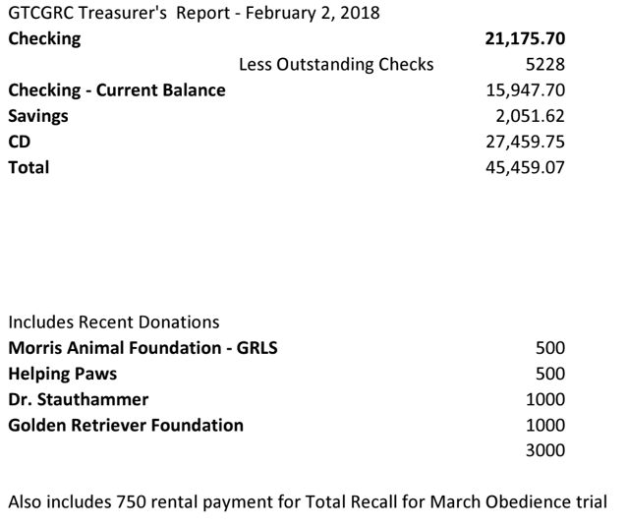

Membership:
- Dues are due! $20 for individual, $25 for Family
- Dues are due before the banquet
- Two prospective members were in attendance for their second meeting
- Three door prizes were raffled by Deb!

Conformation:
- January specialty completed. Both shows filled.
- Raffle brought about $800. Thank you to the volunteers for the show and raffle.
- August specialty being led by Deb, LuAnn and Eileen.

Field:
- WC/WCX date planned for Sunday, September 15 as prior years.

Performance:

Obedience trial:
- March Obedience Trial is approved for March 23-24 at Total Recall in Hugo, MN.
- March 6th closing date
- Application in process for August Specialty
- Volunteers needed.
Health Clinic:
- Health Clinic set for May 4th. Services offered and pricing subject to final approval by Inver Grove staff
- Sign-up sheet to be passed around general meeting for volunteers
- Need about 12 people
Banquet:
- March 2 is the Date!
- A mini-raffle is planned to help support the August Specialty trophies.
Website:
- Charney shared the Alyssa is retiring from the club website. We need a new volunteer for this area.

Board Nominations:
- Charney Petroske has been nominated for President, Michelle Meyer for Vice President, Deb Rahm and Luann Runkle for Conformation and Andrea McConico for field.

Meeting adjourned 8:15 pm

